Activity 1 - DNA Extraction
DNA belongs to the group of acids originally found within the nucleus of the cells, hence the name nucleic acids.
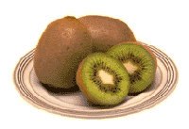
We will extract DNA from fruit to investigate how it looks and feels. This procedure is similar to what scientists have to do before they can use the information contained in this DNA. This information can be used to improve crops so that they are more resistant to disease, insect invasion or changes in climate.

Objectives
- Extract DNA from plant cells
- Understand the general structure of cells

Materials
- 1-small ziplock bag
- 20 ml of extraction buffer
- Skinned kiwi fruit (each fruit cut into 8 pieces) or one large strawberry (each provides ~30 g per student pair)
- 500 ml beaker (class)
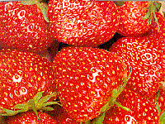
- Cheese cloth
- ice water bath
- Ice cold 95% ethanol (2 ml)
- 1 small test tube
- 1 glass hook
- Transfer pipettes

Procedures
- Cut half of one kiwi fruit or the strawberry into pieces and place in the ziplock bag.
- Add 20mL extraction solution in the zipper bag. Close bag and CAREFULLY squeeze out air.
- Crush the kiwi/strawberry and extraction solution thoroughly for 5 minutes. CAREFUL don’t break the bag!
- Using the ice water bath, alternate cooling the mixture for one minute and continue to press the contents together for one minute. Repeat this three times
- Use the cheese cloth or gauze in a funnel to filter the mixture.
- Using the large transfer pipettes, aliquot approximately 2 ml of the kiwi/strawberry fruit solution into a test tube.
- Add approximately 2 ml of ice-cold ethanol to each tube by dropping it slowly down the side of the test tube, allowing it to rest on top of the kiwi/strawberry fruit mixture. Do not agitate the solution.
- Let the solution sit for two minutes without disturbing it. The DNA stands should form at the junction between the filtrate and the isopropanol and will appear as transparent, slimy, white mucus which can be carefully removed with the glass hook.

